**Girls Uniform**

|  |  |  |  |
| --- | --- | --- | --- |
| **WINTER UNIFORM** | | **SUMMER UNIFORM** | |
| **Branded Uniform - All Pupils**   * Breaside Rucksack (Juniors) * Breaside Book Bag (Infants/Optional for Juniors) * Breaside 3 in 1 Navy Blue Coat (must fit over School Blazer) * Breaside Grey ‘Beanie’ Woollen Hat * Breaside Amber & Grey Scarf (optional) * Breaside Drawstring Bag – for swimming only   **Reception to Year 6 Girls**  Breaside Grey Felt Hat with Amber Hat Band (not Yr6)   * Breaside Grey Blazer * Breaside Grey Cardigan with Amber trim * Breaside Grey Tie * Grey School Tunic (Pleated-skirt optional for Yrs4-6) * Grey knee length Socks with Amber trim or Plain Grey Tights   **Non-Branded Uniform – All Pupils**   * White School Shirt * Black Leather School Shoes (No patent leather or fashion shoes) * Grey Woollen Gloves * Wellington Boots (Navy if possible)   (to be worn to School in bad weather)   * Amber, Black or White Hair Bands and clips.   *Hair that touches the shoulders or is longer must be cut or*  *tied back. Your child’s fringe must be above their eyebrows* | | **Branded Uniform - All Pupils**  Breaside Rucksack (Juniors)  Breaside Book Bag (Infants/Optional for Juniors)  Breaside 3 in 1 Navy Blue Coat – outer layer which zips out (must fit over School Blazer)  Breaside White Sun Hat  **Reception to Year 6 Girls**   * Breaside Straw Boater (not including Year 6) * Breaside Grey Blazer * Breaside Grey Cardigan with Amber trim * Yellow & White striped School Summer Dress   **Non-Branded Uniform – All Pupils**   * Black Leather School Shoes (No patent leather, fashion style or open-toed shoes) * Black Leather School Shoes * White Socks * Amber, Black or White Hair Bands and clips. * *Hair that touches the shoulders or is longer must be cut*   *or tied back. Your child’s fringe must be above their eyebrows* | |
| **ALL CLOTHING, EQUIPMENT & BAGS MUST BE CLEARLY NAMED WITH YOUR CHILD’S NAME!** | | | |
| **EQUIPMENT**  **All Pupils**   * Reading Record Book * (*provided by the School*) * Water Bottle (own or Breaside bottle)   *Only small silver/gold stud earrings may be worn to School. These must be removed for P.E and Fixtures.*  *No other jewellery allowed.* | **Junior Pupils**   * Homework Diary   (*provided by the School*)   * Soft Pencil Case containing:   3x Lead Pencils (HB)   * 2x Blue Ink Pens   (Berol handwriting pen is recommended)  Year 6 pupils may use fountain pens   * Clear plastic 30cm ruler   Rubber   * Pencil sharpener * A set of colouring pencils   NO FELT TIP | | **Junior Pupils**   * Non-toxic paper glue   (e.g. Pritt Stick)   * A Dictionary * A Thesaurus * A set of highlighters * Geometry Set (Yrs 5&6) |

**GIRLS UNIFORM**

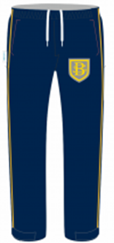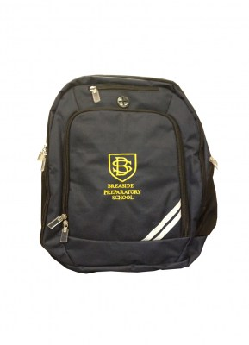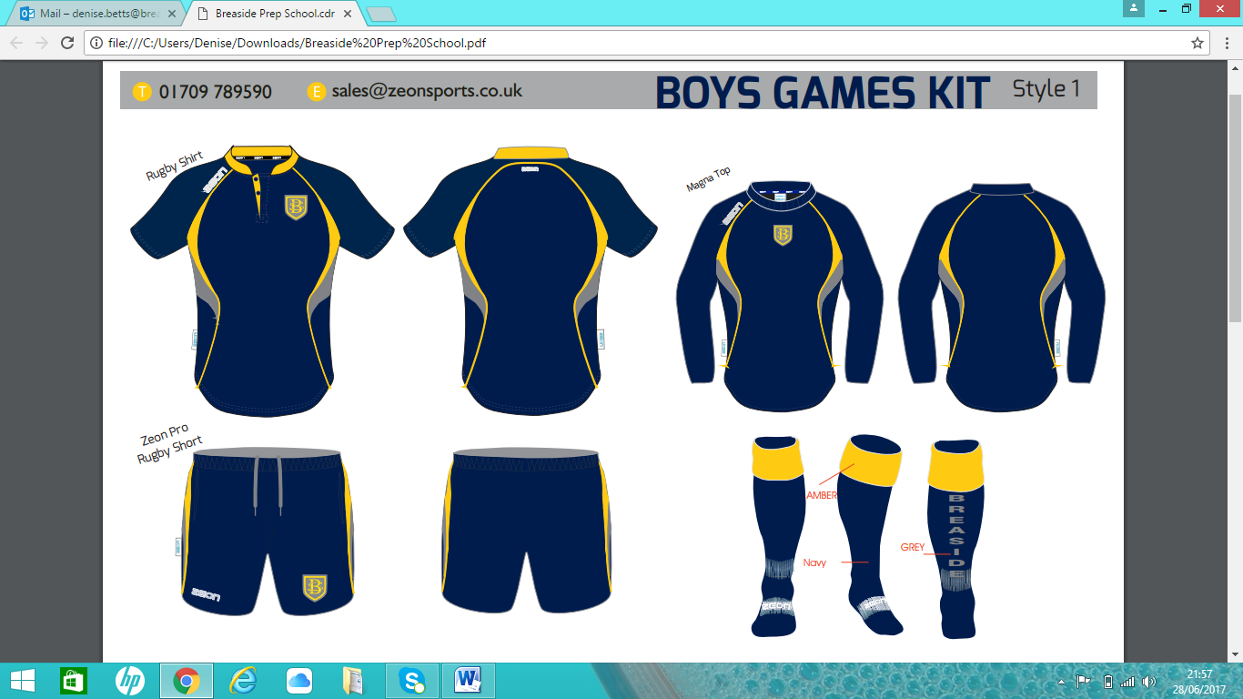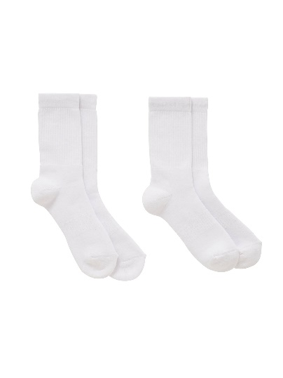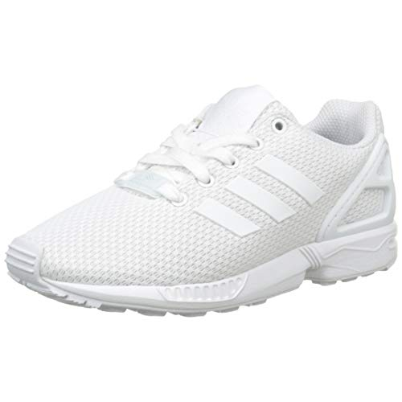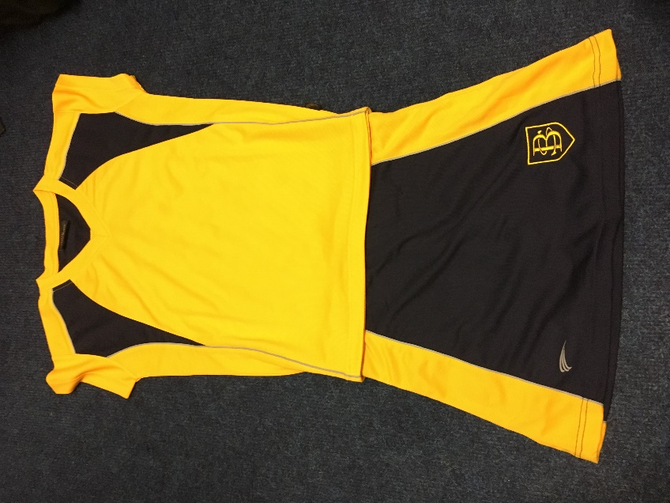 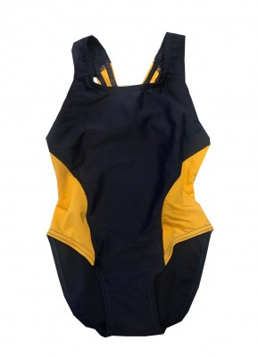

<https://www.ozschoolwear.co.uk/>

[http://breasideprepschool.zeonshop.co.uk](http://breasideprepschool.zeonshop.co.uk/)

<https://www.friendsofbreaside.com/uniform-shop>

Tracksuit

bottoms

**New** Breaside Amber Polo Shirt (Oz School wear)

**New** Breaside Navy Skort (Oz School wear)

**New** Breaside Waterproof Training Top (Zeon)

**New** Breaside Navy Tracksuit bottoms (Zeon)

White Sports Socks (crew style)

White Trainers with white laces

Refillable Water Bottle

Breaside Rucksack (Oz Schoolwear)

Cold or Wet Weather

Breaside Grey ‘Beanie’ Woollen Hat

Base layers ’Skins’ (optional) (Zeon)

Black fingerless ‘grippy’ Gloves (optional from Oz)



**Breaside’s kit requirements for Swimming Lessons**



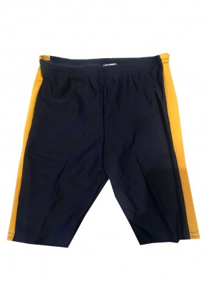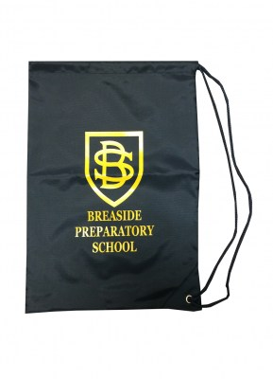

Autumn Term = Years 2 & 3

Spring Term = Years 1 & 4

Summer Term = Reception

Pre-Prep

Year 5

Year 6 = Water Sports in Summer Term

Breaside Swim Bag or Breaside Rucksack

Breaside One-piece Swim-suit (Girls)

Breaside Swimming Trunks (Boys)

Towel & Hairbrush

Yellow Swim Hat (Oz Schoolwear)

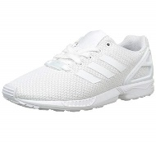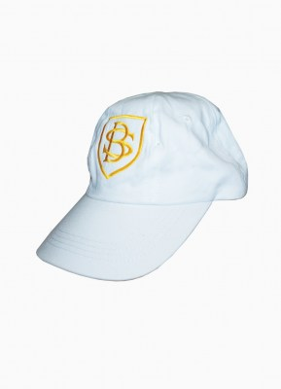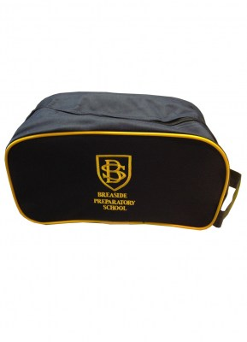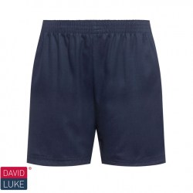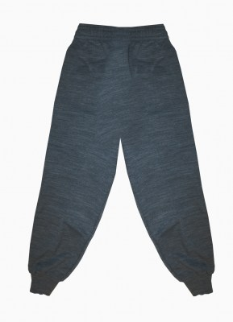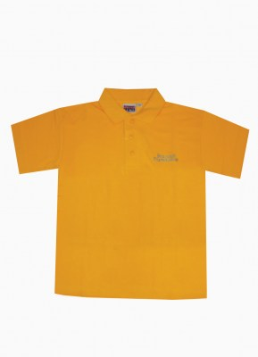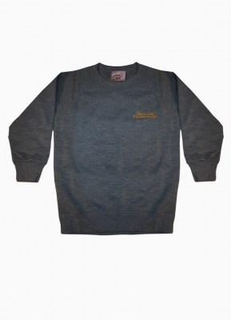

**New** Breaside Waterproof Training Top (Zeon)

Breaside Grey Tracksuit (Oz School wear)

Breaside Amber Polo Shirt (Oz School wear)

Navy PE Shorts (Oz School wear)

White Sports Socks (crew style)

White Trainers with white laces

Refillable Water Bottle

Breaside Rucksack or Breaside Boot Bag (Oz)

Changeable Weather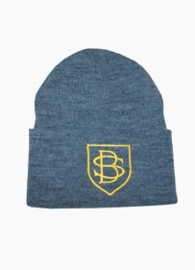

Breaside white Sun Hat

Breaside Grey ‘Beanie’ Hat

Grey or Black Gloves

Swimming Lessons

*(Yr2 - Autumn, Yr1 - Spring, Rec & PP - Summer)*

Breaside Swim Bag or Breaside Rucksack

Breaside One-piece Swim-suit (Girls)

Breaside Swimming Trunks (Boys)

Towel & Hairbrush

Yellow Swim Hat (Oz Schoolwear)

<https://www.ozschoolwear.co.uk/>

[http://breasideprepschool.zeonshop.co.uk](http://breasideprepschool.zeonshop.co.uk/)

<https://www.friendsofbreaside.com/uniform-shop>

**Breaside’s P.E Kit requirements for Infants & Early Years**