**BOYS UNIFORM**

|  |  |  |  |
| --- | --- | --- | --- |
| **WINTER UNIFORM** | | **SUMMER UNIFORM** | |
| **All Pupils**   * Black Leather School Shoes (No patent leather or fashion shoes) * Breaside Rucksack (Juniors) * Breaside Book Bag (Infants) * Breaside Navy Blue Coat (must fit over School Blazer) * Breaside Grey ‘Beanie’ Woollen Hat * Breaside Amber & Grey Scarf (optional) * Grey Woollen Gloves * Wellington Boots (Navy if possible)   (to be worn to School in bad weather)  *Hair that touches the shoulders or is longer must be cut or*  *tied back. Your child’s fringe must be above their eyebrows*  **Kindergarten Boys**   * Breaside Grey School Tracksuit * Breaside Amber Polo Shirt * Short Grey Socks * Black Leather Shoes   **Reception to Year 6 Boys**   * Breaside Grey Felt Cap (not including Year 6) * Breaside Grey School Blazer * Breaside Grey V-neck Jumper with Amber trim * White School Shirt * Breaside Grey Tie * Long Grey Trousers * Grey Ankle or Knee Length Socks with Amber trim * Black Leather School Shoes | | **All Pupils**   * Black Leather School Shoes (No patent leather, fashion style or open-toed shoes) * Breaside Rucksack (Juniors) * Breaside Book Bag (Infants) * Breaside Navy Blue Coat – outer layer which zips out (must fit over School Blazer) * Breaside White Sun Hat   *Hair that touches the shoulders or is longer must be cut or*  *tied back. Your child’s fringe must be above their eyebrows*  **Kindergarten Boys**   * Breaside Grey Sweatshirt * Grey School Shorts * Breaside Amber Polo Shirt * Short Grey Socks * Black Leather School Shoes   **Reception to Year 6 Boys**   * Breaside Grey Felt Cap (not including Year 6) * Breaside Grey School Blazer * Breaside Grey V-neck Jumper with Amber trim * White School Shirt (short sleeves optional) * Breaside Grey Tie * Short Grey Trousers (Year 6 optional)   Grey Ankle or Knee Length Socks with Amber trim   * Black Leather School Shoes | |
| **ALL CLOTHING, EQUIPMENT & BAGS MUST BE CLEARLY NAMED WITH YOUR CHILD’S NAME!** | | | |
| **EQUIPMENT**  **All Pupils**   * Reading Record Book   (*provided by the School*)   * Breaside Book Bag (Infants) * Breaside Rucksack (Juniors) * Water Bottle (own or Breaside bottle – available from Friends of Breaside shop only)   *Only small silver/gold stud earrings may be worn to School. These must be removed for P.E and Fixtures.*  *No other jewellery allowed.* | **Junior Pupils**   * Homework Diary   (*provided by the School*)   * Soft Pencil Case containing:   3x Lead Pencils (HB)   * 2x Blue Ink Pens   (Berol handwriting pen is recommended)  Year 6 pupils may use fountain pens   * Clear plastic 30cm ruler * Rubber * Pencil sharpener * A set of colouring pencils   NO FELT TIPS | | **Junior Pupils**   * Non-toxic paper glue   (e.g. Pritt Stick)   * A Calculator (Non Scientific) * A Dictionary * A Thesaurus * A set of highlighters * Geometry Set (Yrs 5&6) |

Available from **OZ Schoolwear, 6 Chatsworth Parade, Petts Wood, Orgington, Kent BR5 1DF**

Or from the ‘Friends of Breaside’ shop in school



**Autumn Term P.E Kit requirements for Junior Boys**

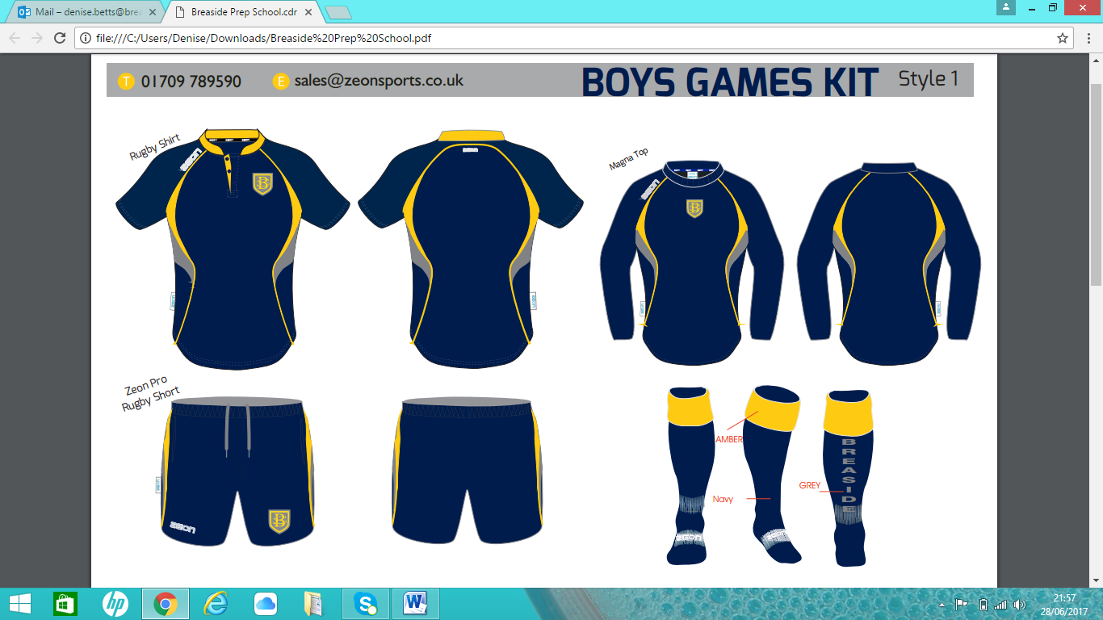

Breaside Waterproof Training Top (Zeon)

Breaside Rugby Shirt (Zeon)

Breaside Rugby Shorts (Zeon)

Breaside knee length Sports Socks (Zeon)

White Trainers with white laces

Black Football Boots (not astroturf boots)

Mouth Guard (Years 3-6)

Breaside Boot Bag (Oz School wear)

Breaside Rucksack (Oz School wear)

Refillable Water Bottle

Cold or Wet Weather

Breaside Grey ‘Beanie’ Woollen Hat

Grey or Navy Gloves (optional)

Base layers ‘Skins’ (optional from Zeon)

**New** Breaside Navy Tracksuit Bottoms (Zeon)

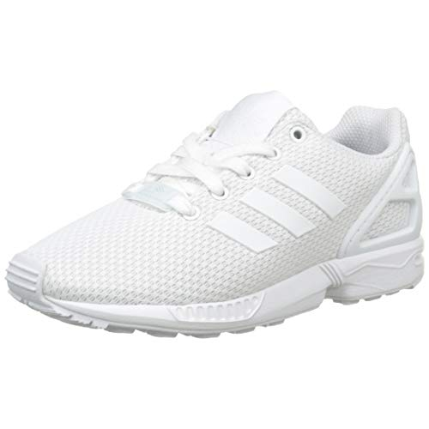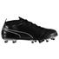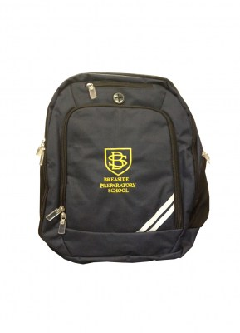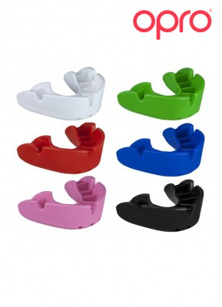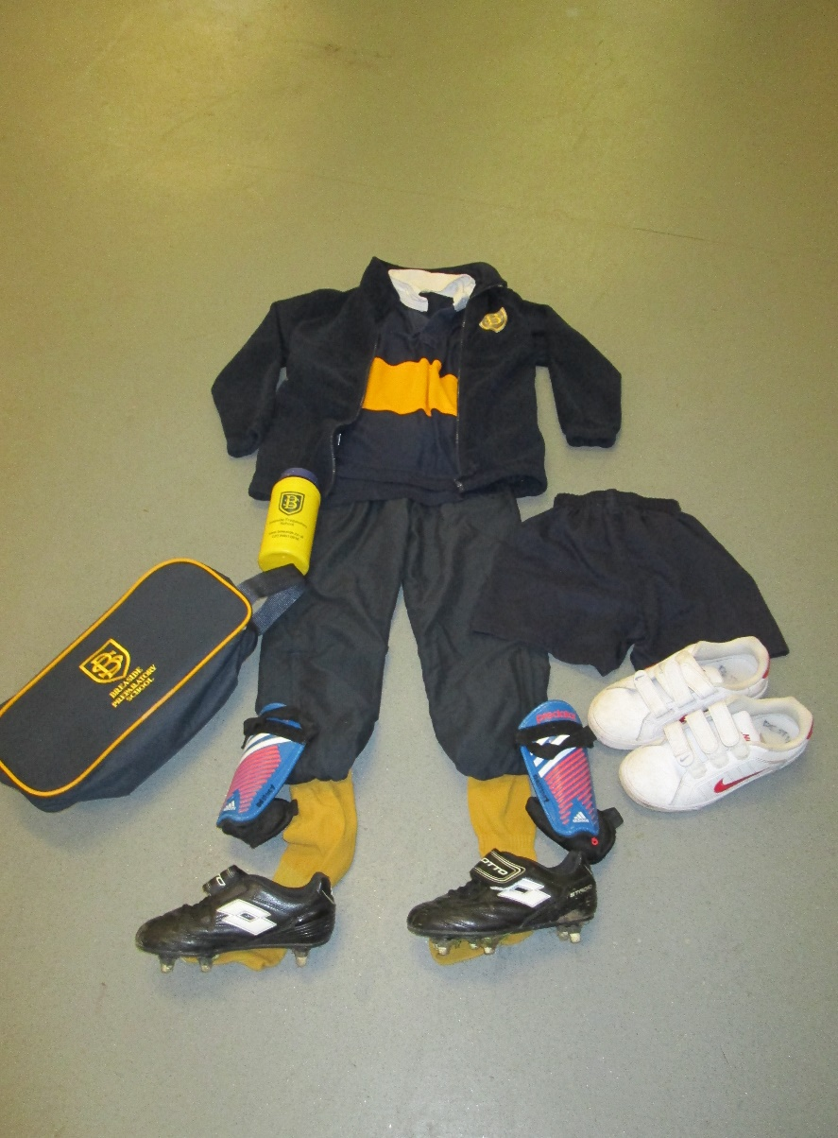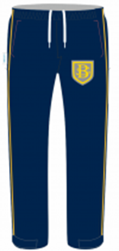

New Tracksuit Bottoms

Base Layers ‘Skins’

<https://www.ozschoolwear.co.uk/>

[http://breasideprepschool.zeonshop.co.uk](http://breasideprepschool.zeonshop.co.uk/)

<https://www.friendsofbreaside.com/uniform-shop>

See separate list for Swimming kit



**Breaside’s kit requirements for Swimming Lessons**

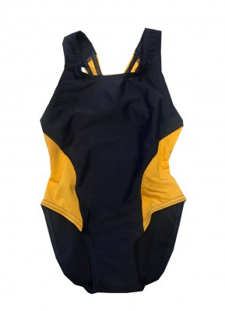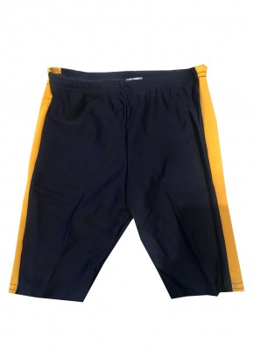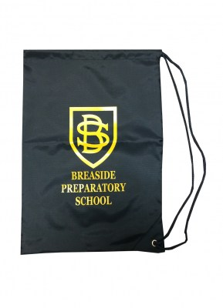

Breaside Swim Bag or Breaside Rucksack

Breaside One-piece Swim-suit (Girls)

Breaside Swimming Trunks (Boys)

Towel & Hairbrush

Yellow Swim Hat (Oz Schoolwear)

Autumn Term = Years 2 & 3

Spring Term = Years 1 & 4

Summer Term = Reception

Pre-Prep

Year 5

Year 6 = Water Sports in Summer Term

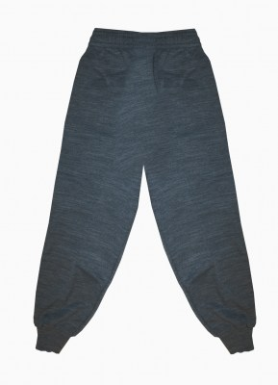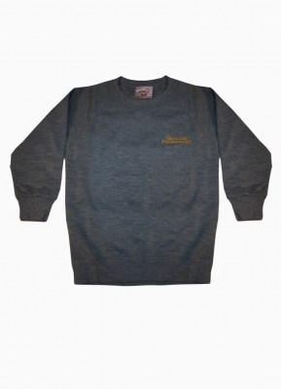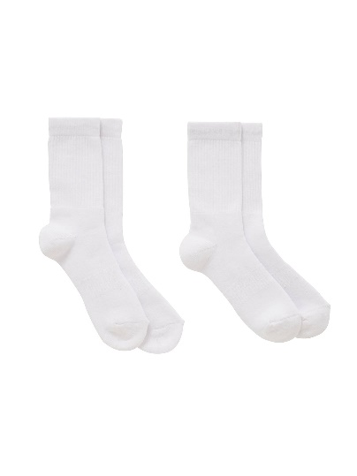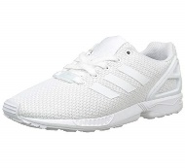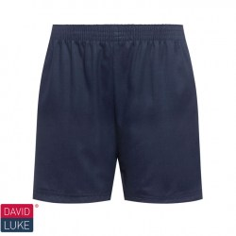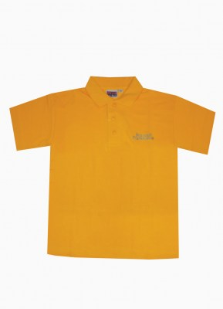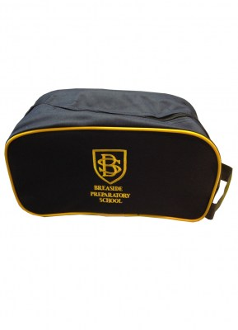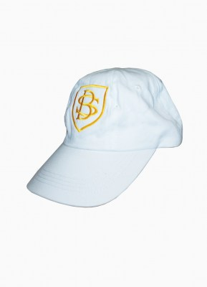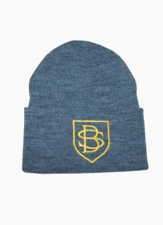

**Breaside’s P.E Kit requirements for Infants & Early Years**

<https://www.ozschoolwear.co.uk/>

[http://breasideprepschool.zeonshop.co.uk](http://breasideprepschool.zeonshop.co.uk/)

<https://www.friendsofbreaside.com/uniform-shop>

**New** Breaside Waterproof Training Top (Zeon)

Breaside Grey Tracksuit (Oz School wear)

Breaside Amber Polo Shirt (Oz School wear)

Navy PE Shorts (Oz School wear)

White Sports Socks (crew style)

White Trainers with white laces

Refillable Water Bottle

Breaside Rucksack or Breaside Boot Bag (Oz)

Changeable Weather

Breaside white Sun Hat

Breaside Grey ‘Beanie’ Hat

Grey or Black Gloves

Swimming Lessons

*(Yr2 - Autumn, Yr1 - Spring, Rec & PP - Summer)*

Breaside Swim Bag or Breaside Rucksack

Breaside One-piece Swim-suit (Girls)

Breaside Swimming Trunks (Boys)

Towel & Hairbrush

Yellow Swim Hat (Oz Schoolwear)